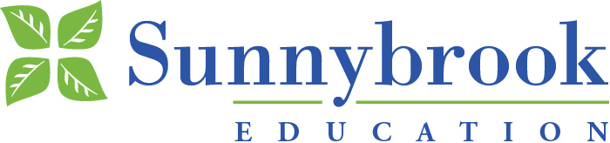
Sunnybrook is Fully Affiliated with the University of Toronto
2017 ATLS Course Schedule
Thursday 1730-2150 Friday 0815 – 1800 Saturday 0715 – 1230

JANUARY 26-28, 2017
FEBRUARY 23-25, 2017
MARCH 23-25, 2017
APRIL 27-29, 2017
MAY 25-27, 2017
JUNE 22-24, 2017
JULY 13-15, 2017
JULY 27-29, 2017
AUGUST 24-26, 2017
SEPTEMBER 28-30, 2017
OCTOBER 26-28, 2017
NOVEMBER 23-25, 2017
DECEMBER 7-9, 2017

For further information please contact:
Terry G. Smith, Manager
Advanced Life Support Educator Program
(ATLS, ACLS, PALS, Ultrasound, BLS)
terryg.smith@sunnybrook.ca 416-480-4943

